

FINAL PROJECT

Section 00313



SUBMITTED BY

Rashmeet Kaur (1896566)

Amritpal Singh Sidhu(1896564)

Anshul Kapoor (1896225)

Khushkirat Singh Virk (1896533)

Raminderjit Singh(1894513)

Deepak Maan(1894830)

TABLE OF CONTENTS

1. ***Project Overview****……...……………………………………..3*
   1. *Purpose of the project…………………………………..3*
   2. *Goal of the project………………………………………3*
   3. *Scope…………………………………………………….3*
2. ***Requirements****…………………………………………….…4*
   1. *Functional requirements……………………………….4*
   2. *Non-functional requirements…………………………..5*
3. ***Use Case Diagram…****……………………………………..7-8*
4. ***Use case scenario****………………………………………9-24*
5. ***Class Diagram****………………………………………….25-26*
6. ***Entity-Relationship Diagram****………………………........27*
7. ***Screen Flow (client side)****……………………………..28-35*
8. ***Screen Flow (Admin Side)****……………………………36-40*
9. ***Data Base Schema****…………………………………….41-45*

*10.* ***References****……………………………………………..…46*

1. **PROJECT OVERVIEW**

**1.1 The Purpose of the project**

An Italian ingredients distributor cited the issues of maintaining different lists for delivered and received products manually. Not only this but it was difficult to view and manage orders, whether they have been received or delivered. He had to analyze the inventory items manually which is very time consuming and is prone to human error as well.

It takes a lot of time and effort to keep a record of your sales and generate manual invoice and send it to the customers. An application which could manage all the above-mentioned problems could prove to be very fruitful to the distributor as well as the consumer because the customer also can manage their account. This could help him generate automatic invoices and send to the generated mails by not wasting useful labour in trivial works.

**1.2 Goal of the project**

The goal of the project to meet requirements at every level for both the Admin and the user. This application is going to help the users (restaurants) maintain the orders, the list of goods which have been ordered, delivered or have been put into a pending list.

The application aims to resolve issues of maintaining manual invoice by replacing it with automatic invoice generation which would then be send to the registered mails automatically. Special notifications would be sent to the customers regarding unauthorized login attempts or delivery updates etc.

**1.3 Scope**

The scope of an inventory system can cover many needs as follows :

* To ensure that the supply of raw material and finished goods will remain continuous to that production process is not halted and demands of customers are duly met.
* To keep inventory at sufficiently high level to perform production and sales activities smoothly.
* To minimize investment in inventory to maximize profitability.
* To reduce the losses of theft, obsolescence etc.
* To minimize loss through deterioration, pilferage, wastages, and damages.
* To optimize various costs indulged with inventories like purchase cost, carrying a cost, storage cost, etc.
* To avoid both overstocking and under-stocking of inventory.
* To eliminate duplication in ordering stocks.

1. **REQUIREMENTS** (Functional and Non-functional)

**2.1 FUNCTIONAL REQUIREMENTS**

|  |  |  |
| --- | --- | --- |
| REQUIREMENT  ID | REQUIREMENT  STATEMENT | MOSCOW  MUST,SHOULD,  COULD,WOULD |
| FR 1 | User must sign up and then login using his/her credentials for using the application. | MUST |
| FR 2 | User can order goods, see the list of pending, received or delivered goods. | COULD |
| FR 3 | User should add the goods to the cart. | SHOULD |
| FR 4 | User could reset the password with the credentials used for signing up. | COULD |
| FR 5 | User Could Cancel the order before accepted by the admin. | COULD |
| FR 6 | Admin should be able to manage CRUD operations. | MUST |
| FR 7 | User gets notified when a new item is added to cart | MUST |
| FR 8 | User can view a list of purchased items in the history. | COULD |
| FR 9 | Maintain right number of products in stock. | SHOULD |
| FR 10 | User can edit their profile information. | COULD |
| FR 11 | User can perform CRUD operations on their end by adding, Deleting Updating the items in the cart. | COULD |
| F12 | User Could search the items from the different Categories | COULD |

**2.2 NON-FUNCTIONAL REQUIREMENTS**

A non-functional is essential to ensure the usability and effectiveness of the entire software system. Failing these requirements can result into failure of customer satisfaction.

**NFR 1 – USABILITY REQUIREMENTS**

The application should be easy to use for users working with restaurant industry, people who have knowledge of online shopping and someone who is fully capable of maintaining and managing the inventory operations. It should be designed in a way that users do not face any problems working with the application or understanding it.

**NFR 2 – PERFORMANCE REQUIREMENTS**

The application should reboot when not working properly without effecting the data of the user and saving it automatically. Bad execution results in negative feedback from the user. It should respond quickly to the user request.

**NFR 3 – IMPLEMENTATION REQUIREMENTS**

The functionalities of the application should be implemented using Android Studio 3.6.3, Fire-base and Just in mind 8.7.7.

**NFR 4 – PORTABILITY REQUIREMENTS**

The application should be able to work at all the versions of android (Oreo, nougat, marshmallow etc.).

**NFR 5 – PRIVACY REQUIREMENTS**

The application does not allow access to personal information to anyone else than the user or the administrator. Nobody can order, change or edit any information on the application without a successful login.

**NFR 6 – MAINTAINABILITY REQUIREMENTS**

The application should be easy to maintain for the administrator which means heshould be able to make any kind of changes (in the prices of the products, he should be able to add or delete products) and these changes made should be made in real time which means for example as soon as there is a change in price of an item the if there is a user using the application, the new price will be reflected.

**NFR 7 – RELIABILITY REQUIREMENTS**

The application should be reliable for making payments for the customer account safety because lack of this could lead to negative feedback from the customers.

1. **USE CASE DIAGRAM**

A UML (Unified modelling language) use case diagram is a primary form to represent system requirements which is still underdeveloped. The use cases just represent the expected working using visual representation and not the exact method of how it is going to happen.

A use case diagram is created using some symbols and notations. For making a use case diagram we used **VISUAL PARADIGM 16.1**. The symbols & notations are explained below:

* **USE CASES**: Horizontally shaved ovals that represent the different uses that a user might have.
* **ACTORS:** Stick figures that represent the people actually employing the use cases.
* **RELATIONSHIPS:** A link between use cases and actors. There are different kind of relationships in a use case diagram which are used in the diagram below.
* **SYSTEM BOUNDARY BOXES**: The rectangle around the use cases is called system boundary box and is the scope of the system. The use cases inside the represent the functionality that you intend to implement.

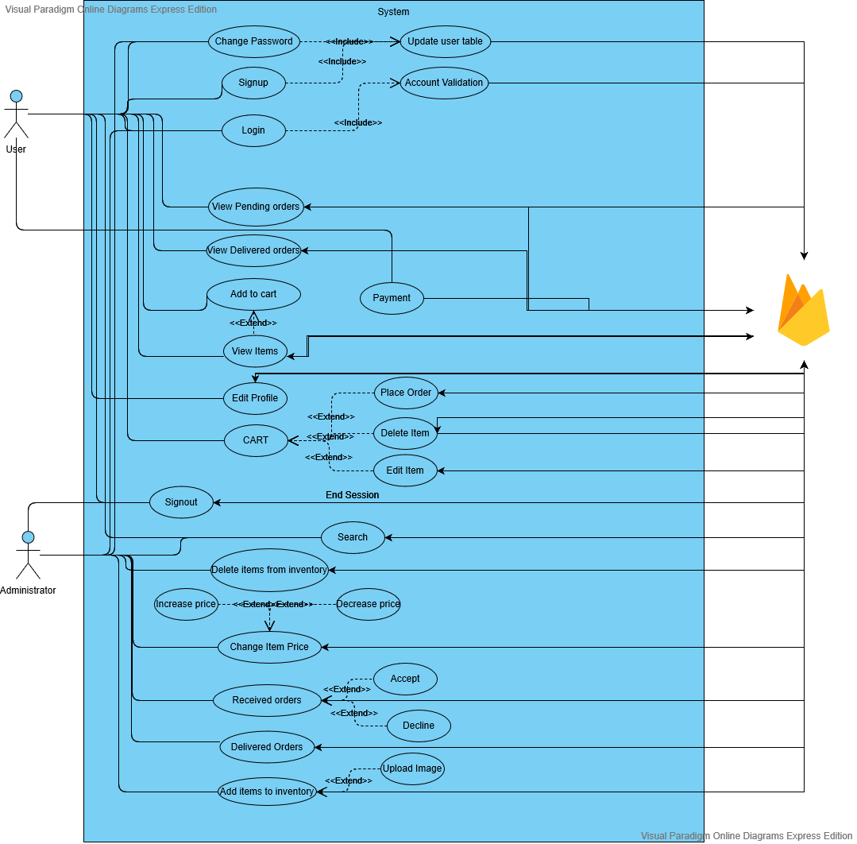

1. **USE CASE SCENARIOS**

**UC1- SIGN UP**

|  |  |  |
| --- | --- | --- |
| System: | SAPORI ITALIANO |  |
|  |  |  |
| Identifier: | UC-1 |  |
|  |  |  |
| Author(s): | Team 7 |  |
|  |  |  |
| Version: | None |  |
|  |  |  |
| Name: | Sign Up |  |
|  |  |  |
| Pre- | The user does not have account on Sapori Italiano. |  |
| Condition(s): |  |  |
|  |  |  |
| Post- | The user is directed to the Login Page of the application. |  |
| Condition(s): |  |  |
|  |  |  |
| Trigger: | The User has clicked on the Sign-up button. |  |
| Normal Flow: | 1. User clicks on Sign Up button to create the user profile. |  |
|  | 1. User enters personal information such as Username, Email, Phone and password to create an account. 2. User information will be updated in table at Firebase server. 3. User is redirected to the Home Page. |  |
| Alternate Flow: | From there, user clicks on Login. |  |
|  |  |  |
| Exceptional | **Exception:** There is an occurrence of internet connection failure. |  |
| Flow(s): | 1. The system will prompt the message “No Internet Connection, try Again”. |  |
|  |  |
|  |  |  |
| Related Actor(s): | **Primary**-New User  **Secondary**-None |  |
| Related Use Case | Login |  |
|  | UC-1: Sign Up New User |  |

**UC2- LOG IN**

|  |  |  |
| --- | --- | --- |
| System: | SAPORI ITALIANO |  |
|  |  |  |
| Identifier: | UC-2 |  |
|  |  |  |
| Author(s): | Team 7 |  |
|  |  |  |
| Version: | None |  |
|  |  |  |
| Name: | Login |  |
|  |  |  |
| Pre- | The user is logged In to account on Sapori Italiano. |  |
| Condition(s): |  |  |
|  |  |  |
| Post- | The user is directed to the homepage specific to the user. |  |
| Condition(s): |  |  |
|  |  |  |
| Trigger: | The user has clicked on the Login button. |  |
|  |  |  |
| Normal Flow: | 1. User clicks on the Login button. |  |
|  | 2. User enters the user name and the password to get logged In. |  |
|  | 3. User clicks on login button. |  |
|  | 4. System will match the details with server. |  |
|  | 5. The dentails are matched. |  |
|  | 6. User is directed to the homepage. |  |
| Alternate Flow: | User clicks on signup button. |  |
|  |  |  |
| Exceptional | **Exception:** If user enters wrong password or username. |  |
| Flow(s): | The system will prompt the message “Wrong User name or password, Try again”. |  |
|  |  |
|  |  |  |
|  |  |  |
| Related | **Primary**-Registered User |  |
| Actor(s): | **Secondary**-None |  |
|  |  |
|  |  |  |
| Related Use | Logout |  |
| Case(s): |  |  |
|  |  |  |
|  | UC-2: Login |  |

**UC-3 –Home**

|  |  |
| --- | --- |
| System: | SAPORI ITALIANO |
|  |  |
| Identifier: | UC-3 |
|  |  |
| Author(s): | Team 7 |
|  |  |
| Version: | None |
|  |  |
| Name: | Home |
|  |  |
| Pre- | 1. The user is registered and has an account on Sapori Italiano |
| Condition(s): | 2. User Logs In with correct username and password |
|  |  |
| Post- | The user is directed to the Home page. |
| Condition(s): |  |
|  |  |
| Trigger: | The user has clicked on the login button. |
|  |  |
| Normal Flow: | 1. User Logs In with correct username and password |
|  | 1. User is directed to home page. 2. System will fetch details from firebase. 3. Entries will be displayed to the user. |
| Alternate Flow: | None |
|  |  |
| Exceptional | There is connection failure. |
| Flow(s): |  |
| Related Actor(s): | **Primary**-Registered User |
| Related Use | None |
| Case(s): |  |
|  | UC-3: Home |

**UC-4– Cart**

|  |  |
| --- | --- |
| System: | SAPORI ITALIANO |
|  |  |
| Identifier: | UC-4 |
|  |  |
| Author(s): | Team 7 |
|  |  |
| Version: | None |
|  |  |
| Name: | My Cart |
|  |  |
| Pre- | 1. The user is registered and has an account on Sapori Italiano |
| Condition(s): | 2. User Logs In with correct username and password  3. User Choose the Options of my cart from bottom. |
|  |  |
| Post- | The user is directed to my cart page. |
| Condition(s): |  |
|  |  |
| Trigger: | The user has clicked on my cart option. |
|  |  |
| Normal Flow: | 1. User is on the home page |
|  | 2. User clicks on my cart option.  3. User is directed to my cart page.  4. System will fetch cart items from Server.  5. User can edit items from cart. |
|  |  |
|  |  |
| Alternate Flow: | None |
|  |  |
| Exceptional | None |
| Flow(s): |  |
|  |  |
| Related | **Primary**-Logged in User |
| Actor(s): |  |
|  |  |
| Related Use | Pending Orders |
| Case(s): |  |
|  |  |
|  | UC-4: Cart |

**UC-5– Pending Orders**

|  |  |
| --- | --- |
| System: | SAPORI ITALIANO |
|  |  |
| Identifier: | UC-5 |
|  |  |
| Author(s): | Team 7 |
|  |  |
| Version: | None |
|  |  |
| Name: | Pending Orders |
|  |  |
| Pre- | 1 The user is registered and has an account on Sapori Italiano |
| Condition(s): | 2. User Logs In with correct username and password  3. User Choose the Options of pending orders from side menu. |
|  |  |
| Post- | The user is directed to pending orders page. |
| Condition(s): |  |
|  |  |
| Trigger: | The user has clicked on pending orders option. |
|  |  |
| Normal Flow: | 1. User is on the home page |
|  | 2. User clicks on the Pending orders button.  3. User is directed to pending orders page.  4. System will fetch orders that has Pending status and display those to user. |
| Alternate Flow: | None |
|  |  |
| Exceptional | None |
| Flow(s): |  |
|  |  |
| Related | **Primary**-Logged In User |
| Actor(s): |  |
|  |  |
| Related Use | Delivered Orders |
| Case(s): |  |
|  |  |
|  | UC-5: Pending Orders |

**UC-6– Delivered Orders**

|  |  |
| --- | --- |
| System: | SAPORI ITALIANO |
|  |  |
| Identifier: | UC-6 |
|  |  |
| Author(s): | Team 7 |
|  |  |
| Version: | None |
|  |  |
| Name: | Delivered Orders |
|  |  |
| Pre- | 1 The user is registered and has an account on Sapori Italiano |
| Condition(s): | 2. User Logs In with correct username and password. |
|  |  |
| Post- | The user is directed to delivered orders page. |
| Condition(s): |  |
|  |  |
| Trigger: | The user has clicked on delivered orders option. |
|  |  |
| Normal Flow: | 1. User is on the home page |
|  | 2. User clicks on delivered orders button.  3. System will fetch items from firebase that has status delivered.  4. System will display delivered orders to the user. |
| Alternate Flow: | None |
|  |  |
| Exceptional | None |
| Flow(s): |  |
|  |  |
| Related | **Primary**-Logged In User |
| Actor(s): |  |
|  |  |
| Related Use | New Orders |
| Case(s): |  |
|  | UC-6: Delivered Orders |

**UC-7 – Profile**

|  |  |
| --- | --- |
| System: | SAPORI ITALIANO |
|  |  |
| Identifier: | UC-7 |
|  |  |
| Author(s): | Team 7 |
|  |  |
| Version: | None |
|  |  |
| Name: | Profile |
|  |  |
| Pre- | 1. The user is registered and has an account on Sapori Italiano |
| Condition(s): | 1. User Logs In with correct username and password. 2. User is on Settings page of the application. |
|  |  |
| Post- | The user is directed to the Profile page. |
| Condition(s): |  |
|  |  |
| Trigger: | The user has clicked on the Edit profile button. |
|  |  |
| Normal Flow: | 1. User clicks on the Edit profile button. |
|  | 2. User edits the personal information in the form. |
|  | 3. User clicks on submit. |
|  | 4. User information will be updated on server. |
| Alternate Flow: | None |
|  |  |
| Exceptional | None |
| Flow(s): |  |
|  |  |
| Related | **Primary**-Registered User |
| Actor(s): |  |
|  |  |
| Related Use | Login |
| Case(s): |  |
|  | UC-7: Profile |

**UC-8–Change Password**

|  |  |
| --- | --- |
| System: | SAPORI ITALIANO |
|  |  |
| Identifier: | UC-8 |
|  |  |
| Author(s): | Team 7 |
|  |  |
| Version: | None |
|  |  |
| Name: | Change Password |
|  |  |
| Pre- | 1. The user is registered and has an account on Sapori Italiano |
| Condition(s): | 2. User is on LOGIN page. |
|  |  |
| Post- | The user is directed to Login page. |
| Condition(s): |  |
|  |  |
| Trigger: | User clicks on Forgot password options. |
|  |  |
| Normal Flow: | 1. User is on the LOGIN page |
|  | 2. User clicks on Forgot password button  3. User is directed to change password page.  4. User enters email address and clicked on validate.  4. If validated, user enters new password and confirm password.  5. Changes will be updated in user table on firebase.  6. User will be directed to login page. |
| Alternate Flow: | None |
|  |  |
| Exceptional | None |
| Flow(s): |  |
|  |  |
| Related | **Primary**-Logged In User |
| Actor(s): |  |
|  |  |
| Related Use |  |
| Case(s): | None |
|  | UC-8: Change Password |

**UC-9–Logout**

|  |  |
| --- | --- |
| System: | SAPORI ITALIANO |
|  |  |
| Identifier: | UC-9 |
|  |  |
| Author(s): | Team 7 |
|  |  |
| Version: | None |
|  |  |
| Name: | Logout |
|  |  |
| Pre- | 1.The user is registered user and has an account on Sapori Italiano.  2. User is on Setting page. |
| Condition(s): |  |
|  |  |
| Post- | The user is directed to Login page. |
| Condition(s): |  |
|  |  |
| Trigger: | User clicks on logout button. |
|  |  |
| Normal Flow: | 1. User is on the home page. |
|  | 2. User chooses Setting button.  3. User clicks on logout button.  4. System will end the current session.  5. User will be redirected to Login page. |
|  |  |
| Alternate Flow: | None |
|  |  |
| Exceptional | None |
| Flow(s): |  |
|  |  |
| Related | **Primary**-Logged In User |
| Actor(s): |  |
|  |  |
| Related Use |  |
| Case(s): | Login |
|  |  |
|  | UC-9: Logout |

**UC-10: Cart**

|  |  |  |
| --- | --- | --- |
| System: | SAPORI ITALIANO |  |
|  |  |  |
| Identifier: | UC-10 |  |
|  |  |  |
| Author(s): | Team 7 |  |
|  |  |  |
| Version: | None |  |
|  |  |  |
| Name: | Cart |  |
|  |  |  |
| Pre- | 1. The user has an account on Sapori Italiano and logged in.  2. The user is on Cart page. |  |
| Condition(s): |  |  |
|  |  |  |
| Post- | Changes will be reflected in the firebase. |  |
| Condition(s): |  |  |
|  |  |  |
| Trigger: | The user has clicked on the editing buttons (increase, decrease, delete) available on the cart page. |  |
|  |  |  |
| Normal Flow: | 1. User click on increase, decrease or delete button. |  |
|  | 1. The changes will be reflected in the cart as well as on the firebase. 2. The user can place the order whenever he want to. |  |
| Alternate Flow: | None |  |
|  |  |  |
| Related | **Primary**-Registered User |  |
| Actor(s): | **Secondary**-None |  |
|  |  |
|  |  |  |
| Related Use | Pending Orders |  |
| Case(s): |  |  |
|  |  |  |
|  | UC-10 cart |  |

**UC-11: Add item**

|  |  |  |
| --- | --- | --- |
| System: | SAPORI ITALIANO |  |
|  |  |  |
| Identifier: | UC-11 |  |
|  |  |  |
| Author(s): | Team 7 |  |
|  |  |  |
| Version: | None |  |
|  |  |  |
| Name: | Add item |  |
|  |  |  |
| Pre-Condition(s): | 1. The user has an account on Sapori Italiano and logged in as administrator.  2. The user has clicked on plus sign available in a particular category which add items. |  |
| Post- | The user is directed to add item page of the application. |  |
| Condition(s): |  |  |
|  |  |  |
| Trigger: | The user has clicked on the plus button available in a particular category. |  |
|  |  |  |
| Normal Flow: | 1. User clicks on plus button on top right corner. |  |
|  | 1. User is redirected to the add item Page. 2. User has to give name, description, quantity and price of the item. 3. User can add image of the item if needed. 4. User clicks on Add item. 5. Item will be added in that particular category. |  |
| Alternate Flow: | None |  |
|  |  |  |
| Exceptional Flow(s): |  |  |
|  |  |  |
| Related | Primary-Administrator |  |
| Actor(s): | Secondary-None |  |
|  |  |
|  |  |  |
| Related Use | Add item |  |
| Case(s): |  |  |
|  |  |  |
|  | UC-11: Add item |  |

**UC-12: Delivered Orders**

|  |  |  |
| --- | --- | --- |
| System: | SAPORI ITALIANO |  |
|  |  |  |
| Identifier: | UC-12 |  |
|  |  |  |
| Author(s): | Team 7 |  |
|  |  |  |
| Version: | None |  |
|  |  |  |
| Name: | Delivered Orders |  |
|  |  |  |
| Pre- | 1. The user has an account on Sapori Italiano and logged in.  2. The user has clicked on Delivered Orders button from bottom navigation bar. |  |
| Condition(s): |  |  |
|  |  |  |
| Post- | The user is directed to Delivered Orders Page of the application. |  |
| Condition(s): |  |  |
|  |  |  |
| Trigger: | The user has clicked on the Delivered Orders button. |  |
|  |  |  |
| Normal Flow: | 1. User clicks on Delivered Orders button to see list of orders that are accepted by admin. |  |
|  | 1. User is redirected to the Delivered Orders Page. 2. System will fetch the list from firebase and display it to user. |  |
| Alternate Flow: | None |  |
| Flow(s): |  |  |
| Related | **Primary**-Registered User |  |
| Actor(s): | **Secondary**-None |  |
|  |  |
| Related Use | Pending Orders |  |
| Case(s): |  |  |
|  | UC-12: Delivered Orders |  |

**UC-13: Pending Orders**

|  |  |  |
| --- | --- | --- |
| System: | SAPORI ITALIANO |  |
|  |  |  |
| Identifier: | UC-13 |  |
|  |  |  |
| Author(s): | Team 7 |  |
|  |  |  |
| Version: | None |  |
|  |  |  |
| Name: | Pending Orders |  |
|  |  |  |
| Pre-Condition(s): | 1. The user has an account on Sapori Italiano and logged in.  2. The user has clicked on Pending Orders button from bottom navigation bar. |  |
| Post-Condition(s): | The user is directed to Pending Orders Page of the application. |  |
| Trigger: | The user has clicked on the Pending Orders button. |  |
|  |  |  |
| Normal Flow: | 1. User clicks on Pending Orders button to see list of orders that he has placed. 2. User is redirected to the Pending Orders Page. 3. System will fetch the list from firebase and display it to user. 4. User can edit or delete items from order. |  |
| Alternate Flow: | None |  |
| Related | **Primary**-Registered User |  |
| Actor(s): | **Secondary**-None |  |
|  |  |
|  |  |  |
| Related Use | Received Orders |  |
| Case(s): |  |  |
|  |  |  |
|  | UC-13: Pending Orders |  |

**UC-14: Search Item**

|  |  |  |
| --- | --- | --- |
| System: | SAPORI ITALIANO |  |
|  |  |  |
| Identifier: | UC-14 |  |
|  |  |  |
| Author(s): | Team 7 |  |
| Version: | None |  |
|  |  |  |
| Name: | Search Item |  |
|  |  |  |
| Pre- | 1. The user has an account on Sapori Italiano and logged in.  2. The user has clicked on Search item at home page. |  |
| Condition(s): |  |  |
| Post- | The user is directed to particular page where the item is present |  |
| Condition(s): |  |  |
| Trigger: | The user has clicked on the search Item. |  |
|  |  |  |
| Normal Flow: | 1. User clicks on search item for searching a particular product. 2. System will match the string with related entries in the firebase. 3. Once matched, system will display those items to user. |  |
| Alternate Flow: | If not matched, system will display message “No result found”. |  |
| Flow(s): |  |  |
|  |  |  |
| Related | **Primary**-Administrator, Registered User |  |
| Actor(s): | **Secondary**-None |  |
|  |  |
|  |  |  |
| Related Use | None |  |
| Case(s): |  |  |
|  |  |  |
|  | UC-14: Search Item |  |

**UC-15: Received Orders**

|  |  |  |
| --- | --- | --- |
| System: | SAPORI ITALIANO |  |
|  |  |  |
| Identifier: | UC-15 |  |
|  |  |  |
| Author(s): | Team 7 |  |
|  |  |  |
| Version: | None |  |
|  |  |  |
| Name: | Received Orders |  |
|  |  |  |
| Pre- | 1. The user has an account on Sapori Italiano and logged in.  2. The user has clicked on Received Orders button. |  |
| Condition(s): |  |  |
| Post- | The user is directed to Received Orders Page of the application. |  |
| Condition(s): |  |  |
| Trigger: | The user has clicked on the Received Orders button. |  |
|  |  |  |
| Normal Flow: | 1. User clicks on Received Orders button to see list of orders. 2. User is redirected to the Received Orders Page. 3. System will fetch the orders that are placed by users. 4. System will display the result. |  |
| Alternate Flow: | None |  |
|  |  |  |
| Flow(s): |  |  |
|  |  |
|  |  |  |
| Related | **Primary**-Administrator |  |
| Actor(s): | **Secondary**-None |  |
|  |  |
|  |  |  |
| Related Use | None |  |
| Case(s): |  |  |
|  | Uc-15 Received Orders |  |

**UC-16: Payment**

|  |  |  |
| --- | --- | --- |
| System: | SAPORI ITALIANO |  |
|  |  |  |
| Identifier: | UC-17 |  |
|  |  |  |
| Author(s): | Team 7 |  |
|  |  |  |
| Version: | None |  |
|  |  |  |
| Name: | Payment |  |
|  |  |  |
| Pre-Condition(s): | 1. The user has an account on Sapori Italiano and logged in.  2. The user has clicked on Place order Button in his cart.  3.The user is directed to make payment page. |  |
| Post-Condition(s): | The user is directed to make payment page of the application. |  |
| Trigger: | The user has clicked on the place order button. |  |
|  |  |  |
| Normal Flow: | 1. User clicks on place order button in his cart. 2. User is redirected to the make payment page. 3. User has to fill in the card details. 4. User clicks on make payment button to pay the invoice. |  |
| Alternate Flow: | None |  |
| Exceptional Flow(s): | 1. The details entered are not correct. 2. There is connection failure. |  |
| Related Actor(s): | **Primary**-Administrator  **Secondary**-None |  |
| Related Use | None |  |
| Case(s): |  |  |
|  | UC-16:Payment |  |

1. **CLASS DIAGRAM**

A class diagram is a type of static structure diagram that describes the structure of the system by showing the system’s:

1. **Class:** A class is blueprint of an object. These two go hand in hand and we can’t talk about one of them without mentioning the other. Every class describes a type of object.
2. **Attributes:** An attribute represents a characteristic of a class that is of interest for the user of the IT system.
3. **Operations** (or methods): An operation is a method or a function that can be performed by an instance of a class or interface.

In a class diagram class is represented with boxes that contain three compartments:

* The top compartment contains the name of the class. First letter for the class name is capital.
* The middle compartment contains the attributes of the class. .
* The bottom compartment contains the operations the class can execute.

Association in classes:

Association is basically a relationship between the two different classes , how two different classes and their  attributes interact with each other.

Some different form of association is discussed as below**:**

1. **Association**: Both classes are equal.

**For example:**

A person may own none, one or many cars, and a car must have one or many owners. And they are at the same level, none of them is a part of the other.

1. **Aggregation:** Illustrated with an open diamond. We have a hierarchy where the class on the diamond end is the whole, and the class on the other end is a part.
2. **Composition:** Illustrated with a filled diamond. The class on the diamond end owns the class on the other end.

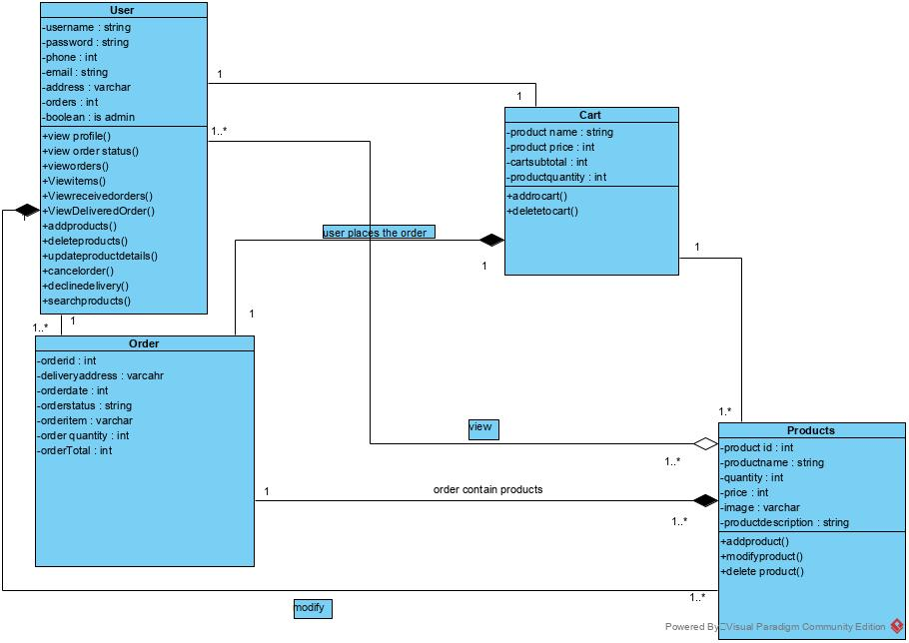

1. **ENTITY-RELATIONSHIP DIAGRAM(ERD)**

Entity Relationship Diagram, also known as ERD, ER Diagram or ER model, is a type of structural diagram for use in database design. An ERD contains different symbols and connectors that visualize two important information: **The major entities within the system scope**, and the **inter-relationships among these entities**.

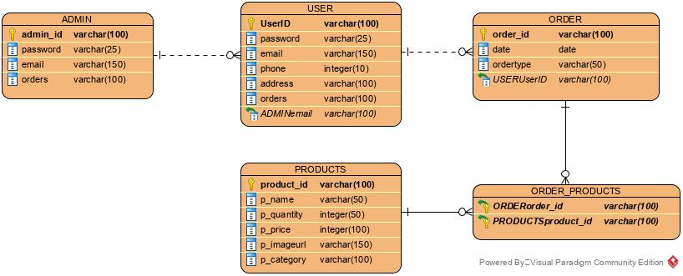

1. **SCREEN FLOW**

* *Client Side*
* Splash Screen

This is the first screen which will appear when user runs the application.



* Client and Admin Login

This screen appears after splash screen from which user can login, sign up and change its password. It contains toggle buttons for user and admin.

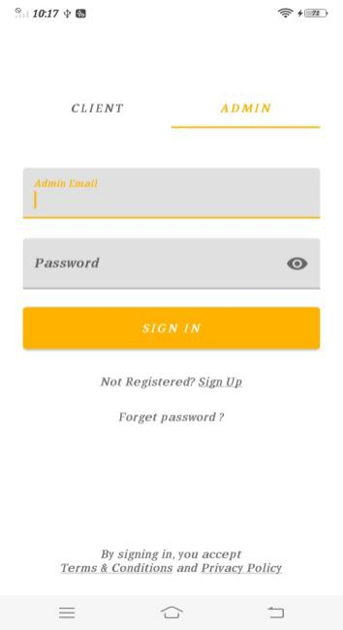

* Sign up

From this screen user can fill its credentials to sign up for this application.

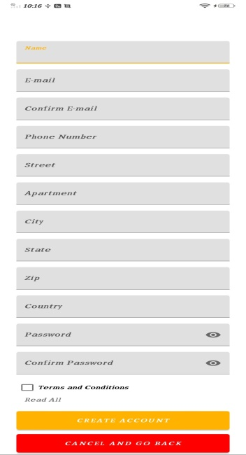

* Terms and Conditions

This is terms and condition page which appears when user clicks on the check box to accept the terms and conditions to use this application.

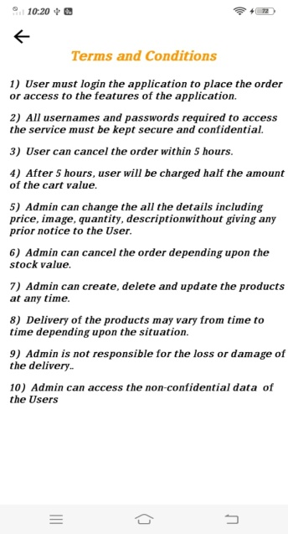

* Forgot Password

This screen opens when user clicks on forgot password on Admin and client login screen.

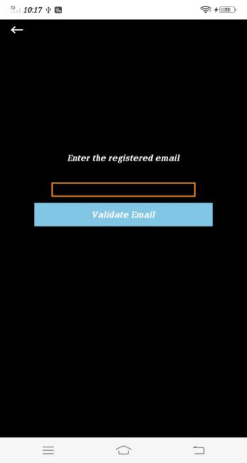

* Home Screen

This screen appears when client is successfully logged in the application.

This screen has search option, categories available and bottom navigation bar with black background.

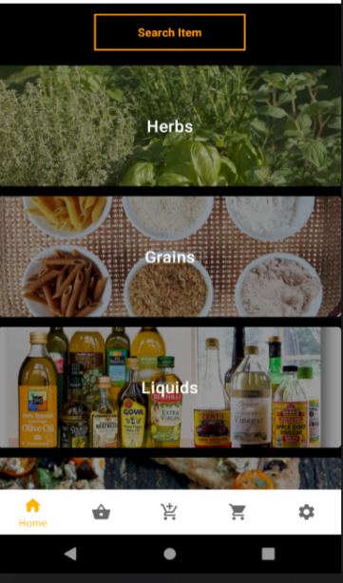

* Items in Specific Category

This screen appears when user clicks on particular category which shows all the items available with image, name and price.

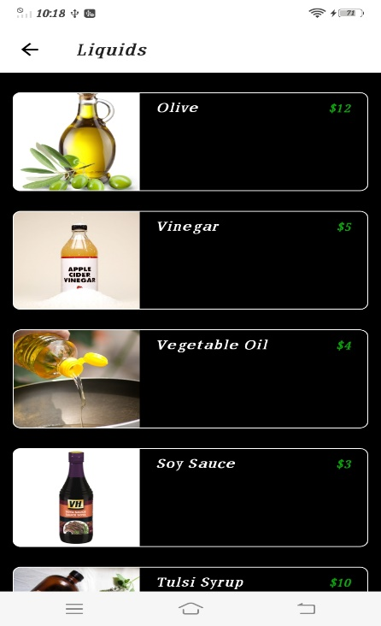

* Product Details

This screen opens when the user choose a specific item from the list.

This page shows item name, item details, weight, price per item, items in stock and gives users the option to choose item the want to buy (max 10).

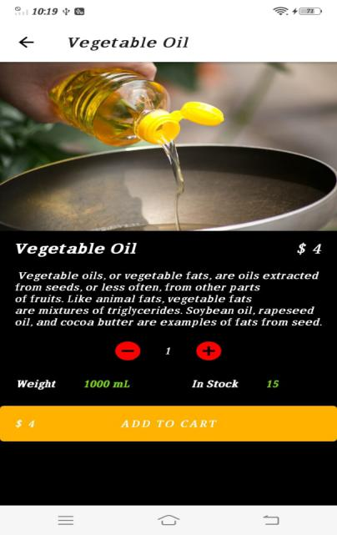

* User’s cart

The is user’s cart page it opens when user add product to cart.

It gives option to add or subtract the number of items and option to delete whole item from the cart .It Shows Subtotal of items in cart.

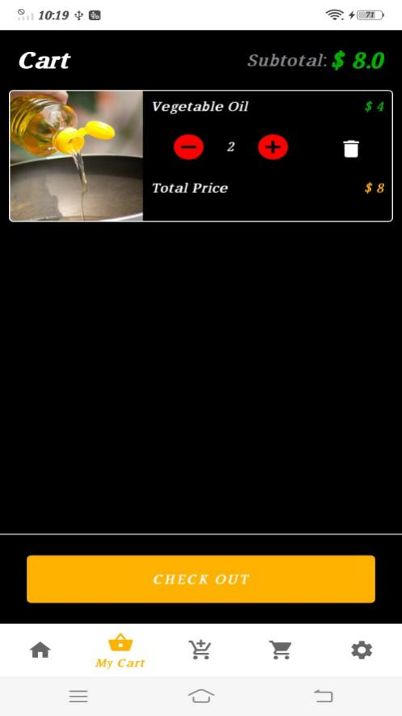

* Shipping Address

When user clicks on checkout button it prompt this screen on which user can fill their desired address and can make changes to it.

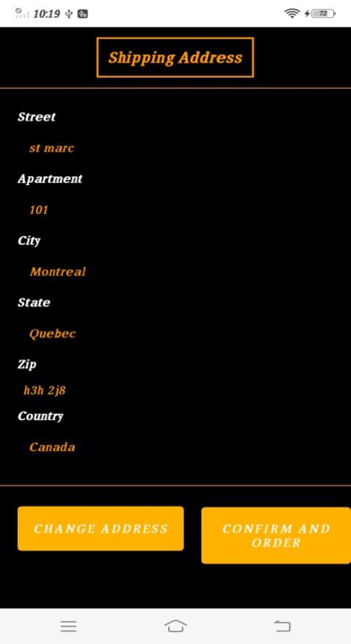

* Make Payment

When user clicks on confirm and order button on shipping address page it opens payment page where client enters it valid credentials to make payment via PayPal.

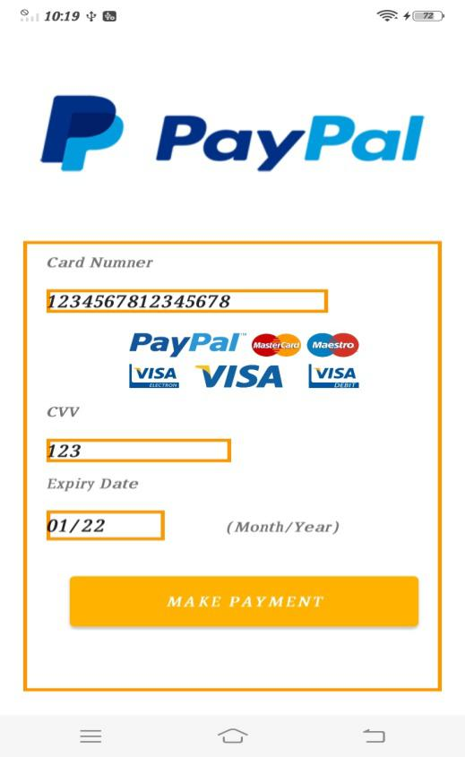

* Order Paced{Toast}

When the order is successfully placed it bring back user to home page and show the toast at the bottom.

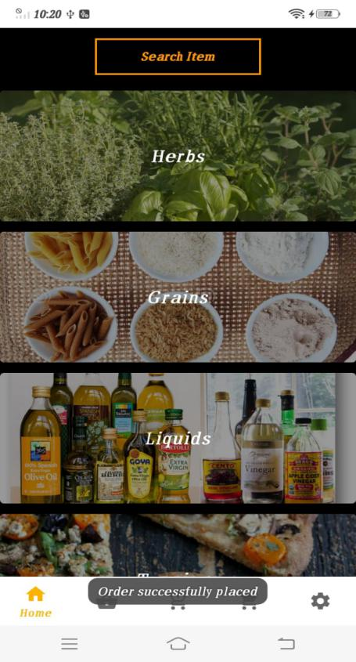

* Pending Orders Fragment

User has chosen pending orders from bottom navigation bar. It gave user option for canceling the order and also shows the status of the order.

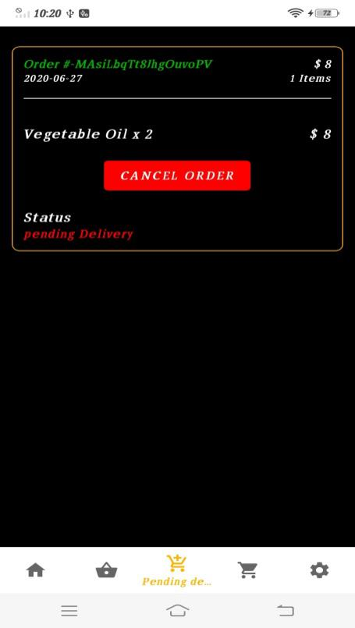

* Delivered Orders Fragment

User has chosen delivered orders from bottom navigation bar. It shows orders which are being successfully delivered to user.

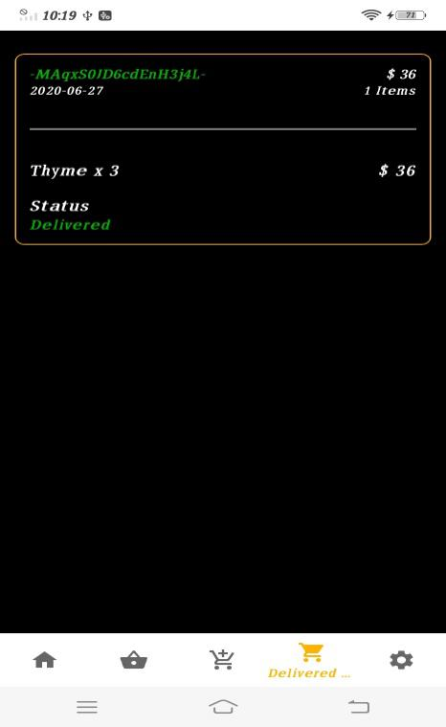

* Settings

User has chosen settings from bottom navigation bar which provides options for logging out the user account and change user details.

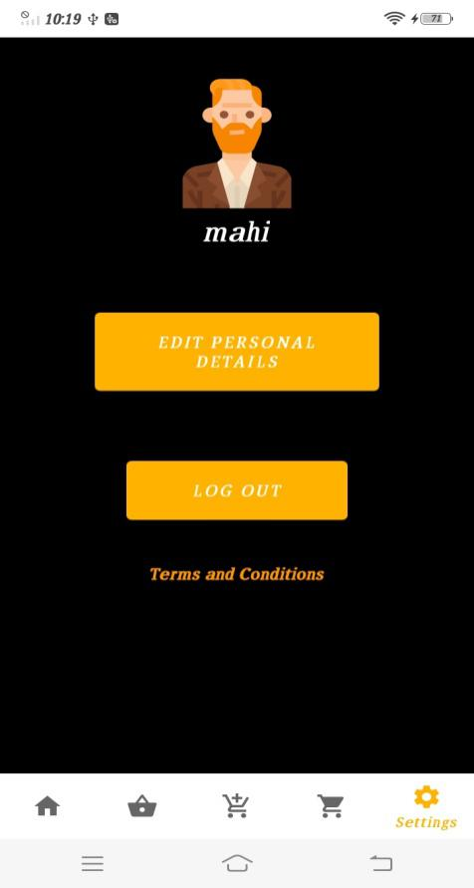

* Edit Details by Client

This page helps user to edit personal profile.

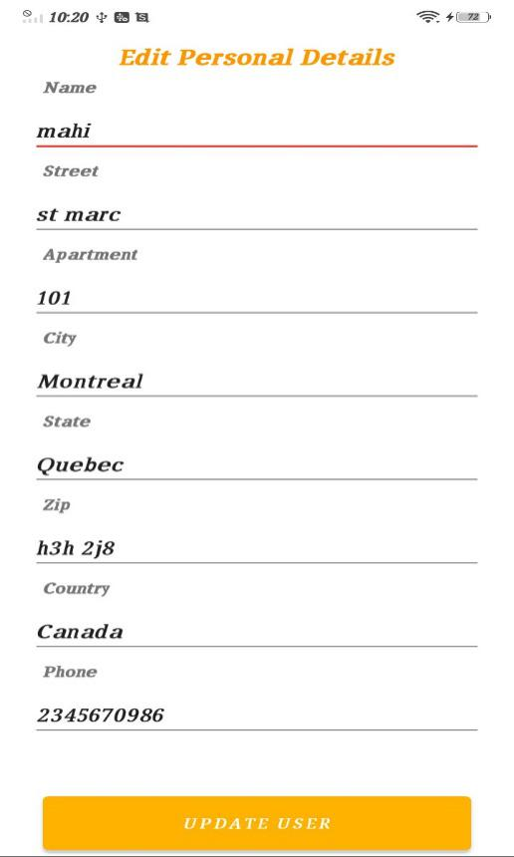

* *Admin Side*
* Admin Login Side

This screen appears after splash screen from which user can login, sign up and change its password. It contains toggle buttons for user and admin.

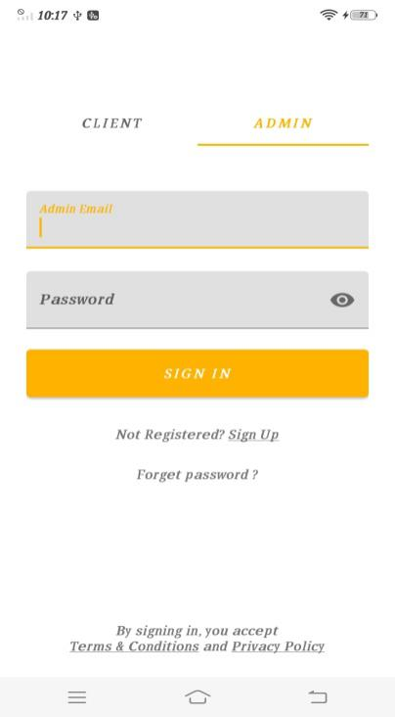

* Home Page (Admin Side)

This screen appears when admin is successfully logged in the application. This screen has search option, categories available and bottom navigation bar with white background.

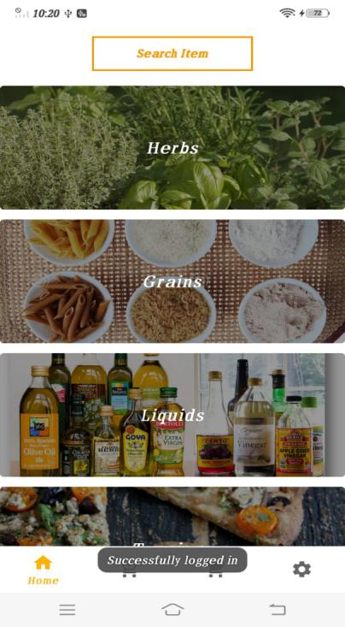

* Items at Admin End

This page opens when admin enters particular category of herbs. Admin

Can add new items into the category and can even delete any item.

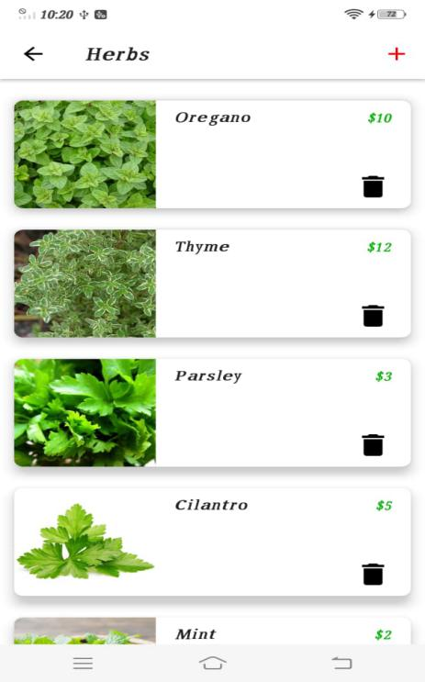

* Edit Items

Items being edited by admin.

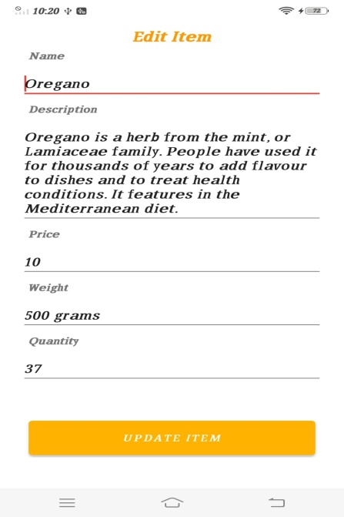

* Add New Items

Admin Clicks on Plus sign on top right corner to add new products.

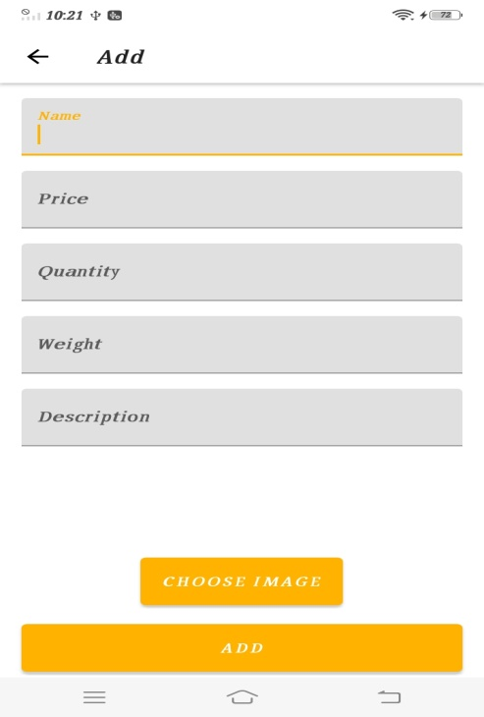

* Delivered orders

The admin has selected delivered orders from bottom navigation bar.

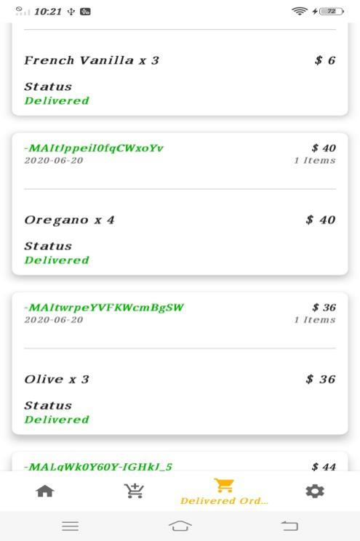

* Received orders

The admin has selected received orders from bottom navigation bar.

Admin has privilege to accept or decline the order.

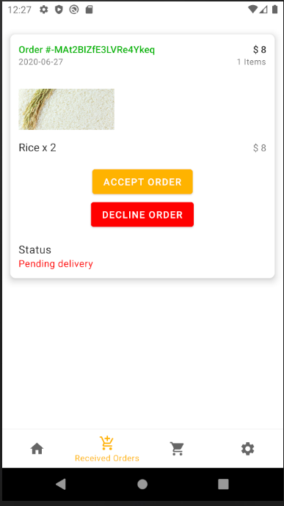

* Settings

Admin has chosen settings from bottom navigation bar which provides options for logging out the admin account and change admin details.

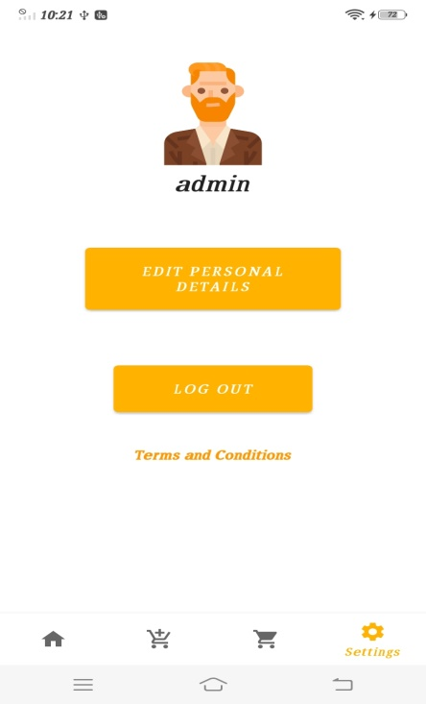

**Data Base Schema:**

Data base is the core feature of the application .It makes the application fast, flexible, easy to use at anywhere. In this Inventory ordering and management application we are using the fire base database which is very efficient and fast to use.

**Category** for the products and **User** are basic building tables of the application

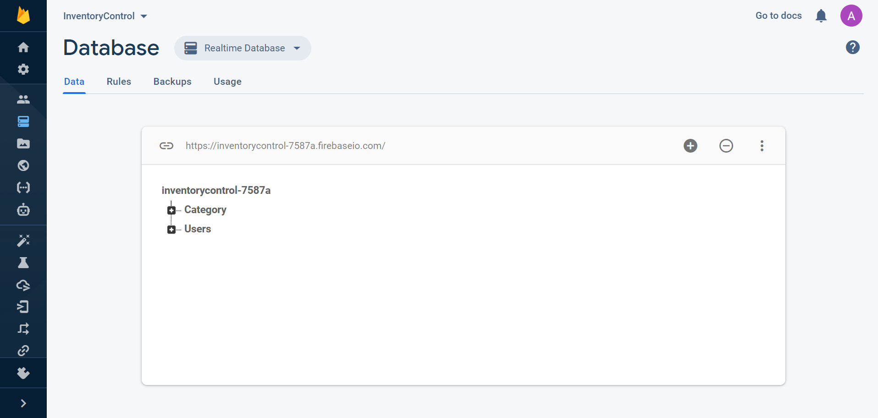

Here are the expanding the main nodes Category and users respectively.

We have 4 main Categories of ingredients and many users

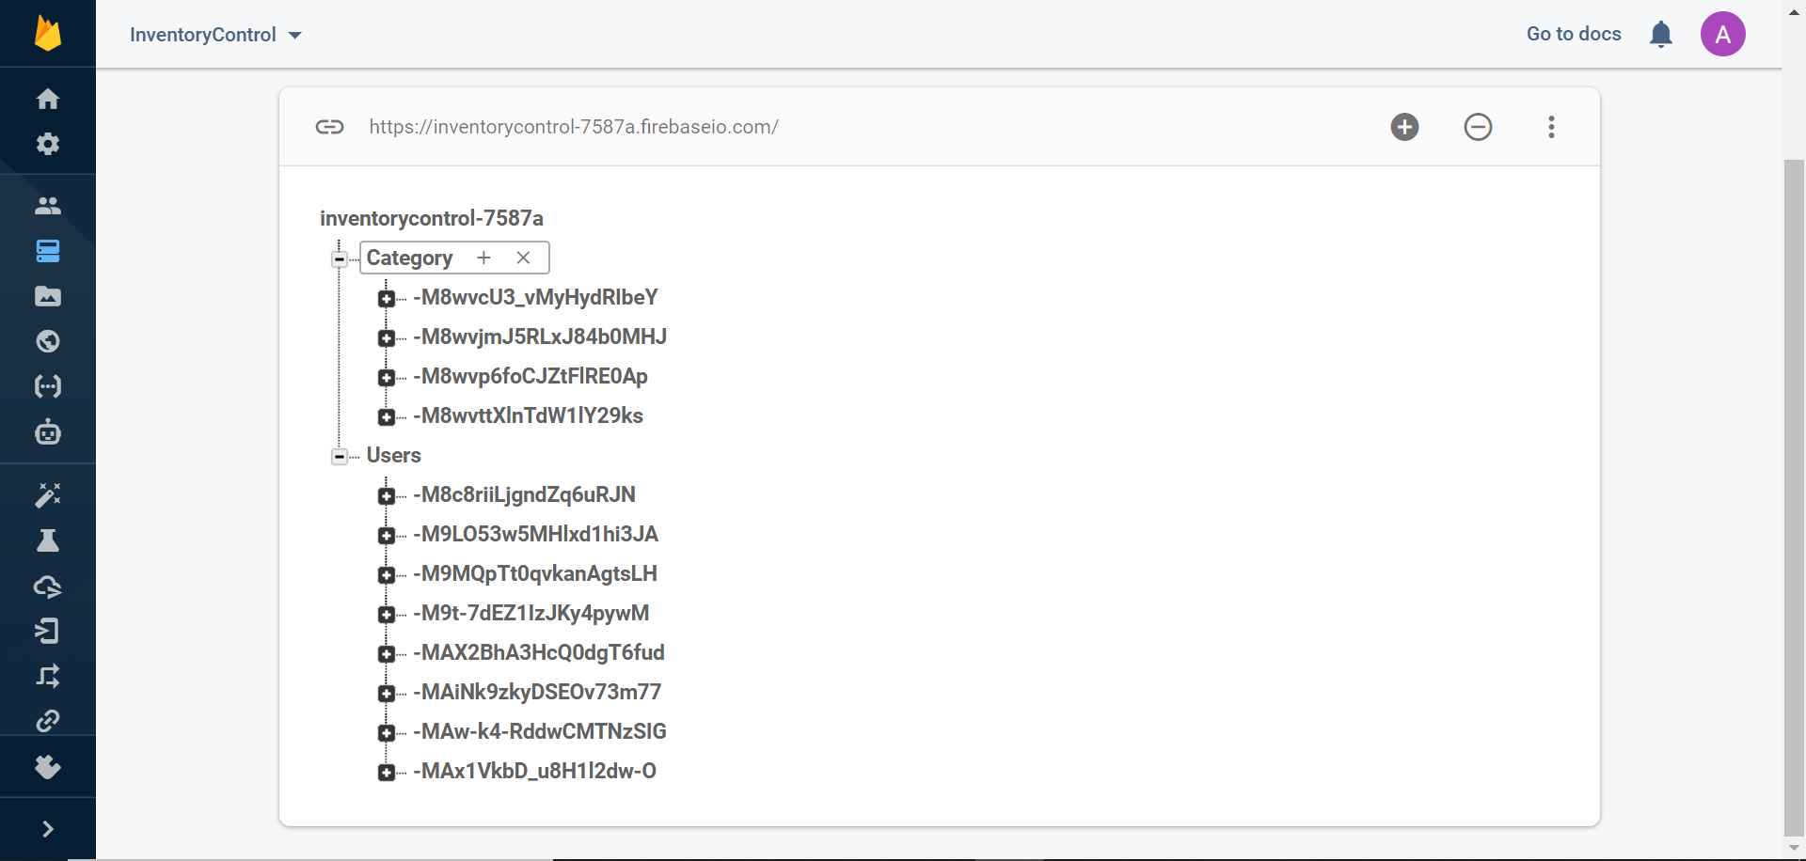

**Random id generation for each category.**

**Unique id generation for all users.**

Expanding further the category node, we can see the child nodes and every value has a unique key generated by the Firebase when we push the data to the database. **Expanding the data for the herbs section.**

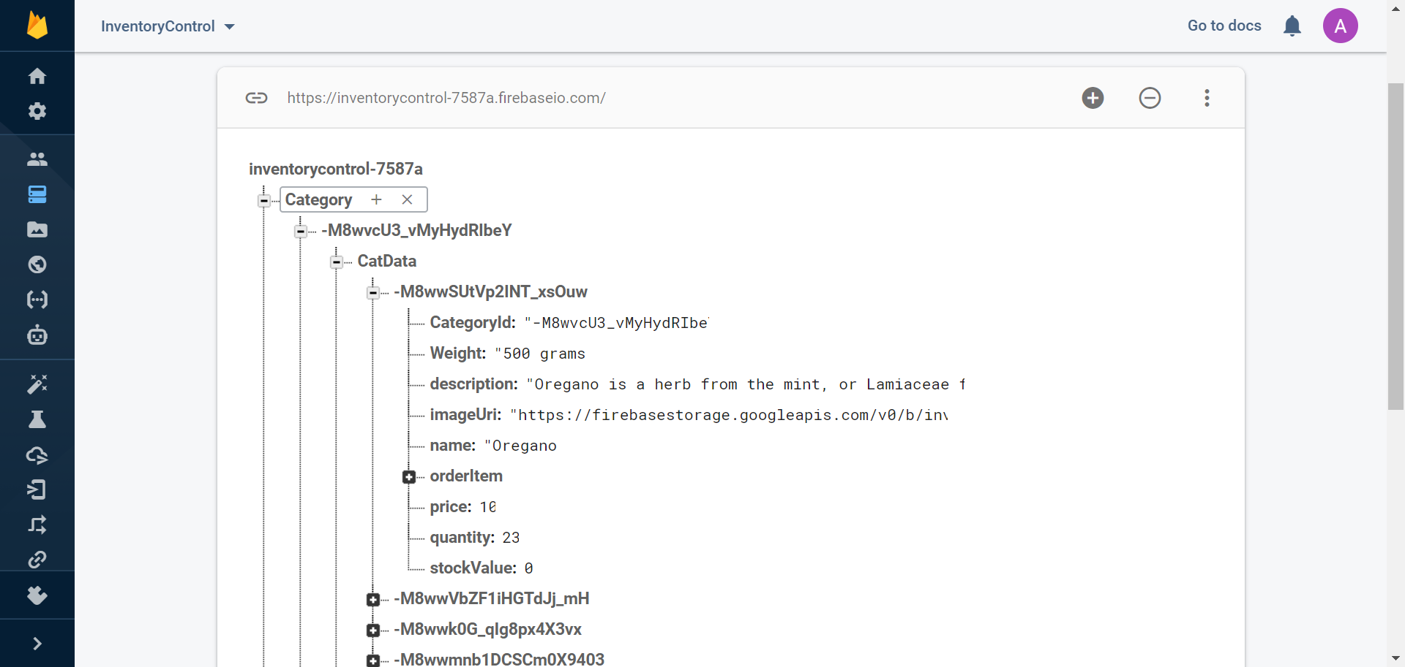

**Key and the values for the different ingredients**

**Unique key for every ingredient under the category cat data**

In this section we are expanding the main node of the user and from the child node we further expand the details of admin with all the key and values like the details of the user and the orders of the user.

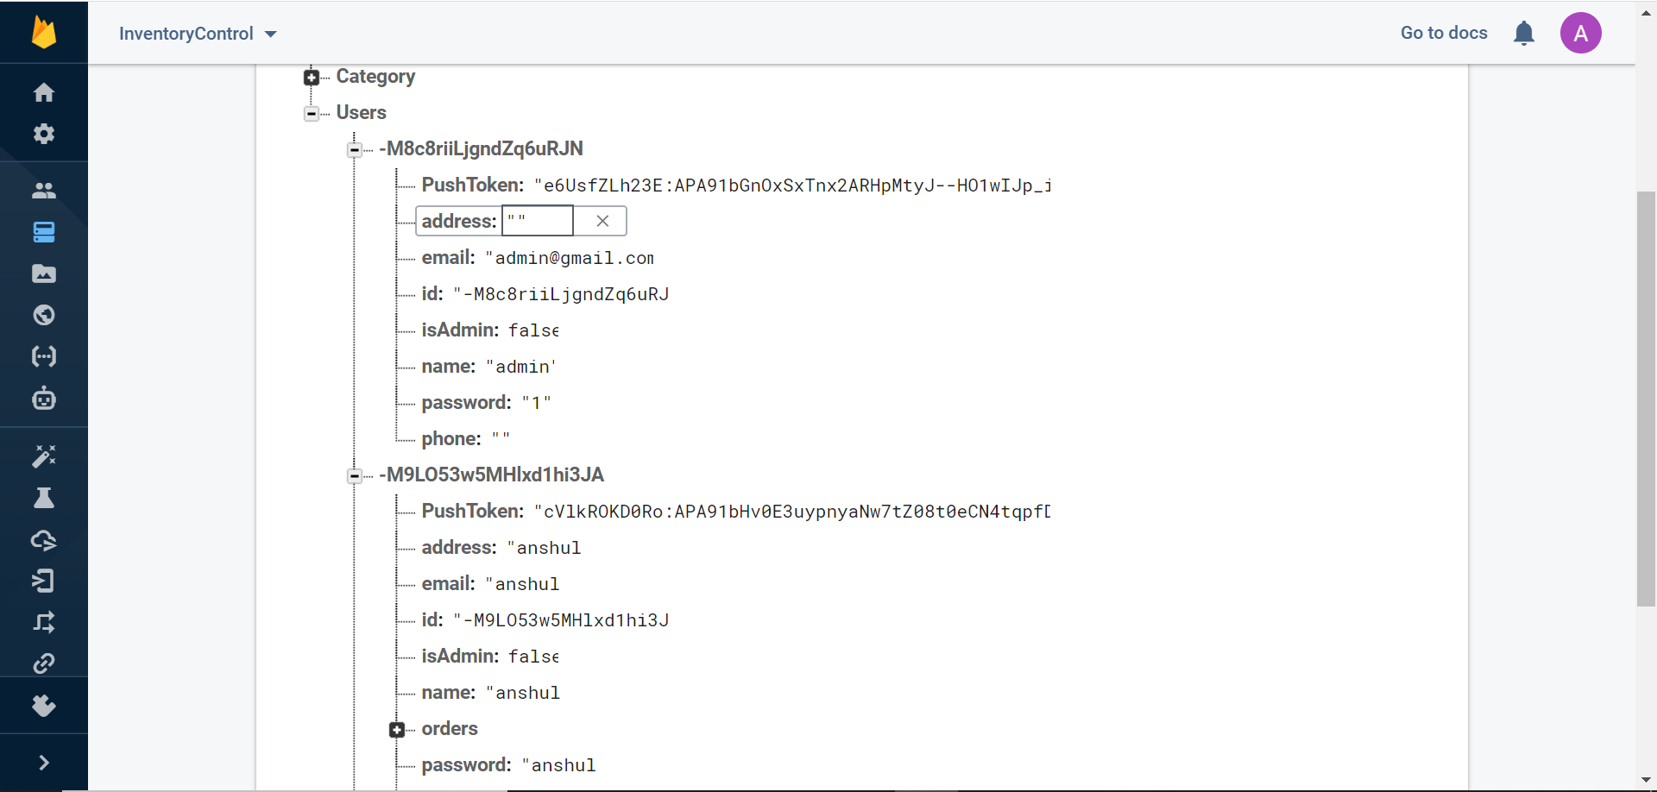

**Different users with unique firebase id**

**Expanding the child node for the specific user**

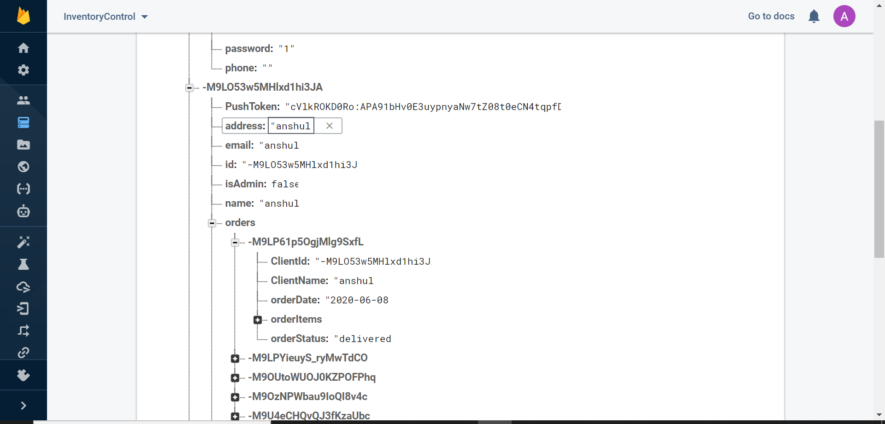

User details with ordered items

Expanding the child node u under the user order section

**References**

<https://developer.android.com/>

<https://stackoverflow.com/>

<https://www.udemy.com/>

<https://www.geeksforgeeks.org/>

<https://www.javatpoint.com/>